Project Plan

Document Number: SWE7903-Spring2026-Team1-PP01
Date: 05/06/2026

Reservation Support Chat Platform
Team Members:
- John Pranoy Yalla (Team Lead)
- Walter Hernandez
- Varun Vemuri
- Samir Mendrani

Client: Vacations For You

Table of Contents
1. Introduction 3
1.1. Problem Statement 3
1.2. Proposed Solution 3
2. Project Overview 3
2.1. Scope 3
2.1.1. Identification 5
2.1.2. System Overview 5
2.1.3. Document Overview 5
2.2. Background, Objectives, and Scope 6
2.3. Operational Policies and Constraints 6
2.4. Requirements 6
2.4.1. Functional Requirements 6
2.4.2. Non-Functional Requirements 7
2.5. Supported vs Unsupported Question Taxonomy 7
2.5.1. Supported Questions 7
2.5.2. Unsupported Questions 8
2.6. UI Wireframes 8
2.7. Users or Involved Personnel 10
2.7.1. End Users 10
2.7.2. Internal Stakeholders 11
3. Development Background/Approach 12
3.1.1. Frontend Layer 12
3.1.2. Backend Layer 13
3.1.3. LLM Integration Layer 13
3.1.4. Data Access Layer 13
3.2. API and Data Integration Plan 13
3.2.1. Data Sources 13
3.2.2. API Endpoints 13
3.2.3. Integration Plan 17
3.3. High Level Estimates 17
3.4. Evaluation Metrics 17
3.4.1. Accuracy Metrics 17
3.4.2. Coverage Metrics 18
3.4.3. Operational Metrics 18
3.5. Key Contacts and Stakeholders 18
4. Features, Primary Deliverables, and External Commitments 18
4.1. Feature List 18
4.2. Customer Deliverables 19
5. Project Schedule 19
6. Project Resource Requirements 20
6.1. Staffing/ Skill Requirements 20
6.2. Plan to Fill Skill Gaps 21
7. Dependencies and Constraints 21
7.1. Constraints 21
8. Risk Management 21
9. Project Configuration and Data Management 22
9.1. Configuration Management 22
9.1.1. Version Control 22
9.1.2. Branching Strategy 23
9.1.3. Change Management 23
9.1.4. Configuration Files 23
10. Project Process 23
10.1. Software Life Cycle Model 23
11. Glossary 23
12. Change Record 24

Introduction
Vacations for You (VFU) operates a high-volume vacation rental business and handles a significant number of post-booking guest inquiries through a traditional call-center workflow. These inquiries often involve routine questions about existing reservations, property details, policies, and next steps. This capstone project will deliver a Phase 1 proof-of-concept (POC) for a web-based, AI-assisted guest support chat experience that helps guests with existing reservations only. The system is intended to reduce call-center load by answering common questions accurately and consistently while providing a clear escalation path when human support is required. This project is not a booking or sales system. It focuses exclusively on after-booking support and is designed to validate feasibility, usability, and operational impact before deeper investment.

Problem Statement
The current call-center model creates several operational and guest experience challenges:
- High operational costs for handling routine, repetitive inquiries.
- Limited availability outside business hours when guests may need information most.
- Inconsistent response quality depends on individual agent knowledge and experience.
- Extended wait times during peak booking seasons and weekends.
- Inefficient use of trained staff on questions that could be reliably automated.

Proposed Solution
This project aims to develop an AI-assisted chat interface that allows guests who have already booked to receive immediate, accurate answers to common post-booking questions. The system will utilize modern large language models (LLMs) combined with data sources to provide contextually relevant and accurate responses based on each guest's specific reservation and property details. The solution is designed around three core principles:
- Accuracy over coverage: The system will confidently handle a defined set of common inquiries and clearly escalate to human support when questions fall outside its scope depending on the confidence value which we set in the Code.
- Guest-centric design: Responses will be personalized based on actual reservation and property data which will be accessed by API Call to Clients StreamX Portal.

Project Overview

Scope
This software project is meant to reduce significant call volumes by efficiently implementing an AI Chatbot application, which will be accessible through the website homepage (if the POC is approved). It will be able to provide customers with information regarding their reservations. Providing an efficient form to communicate reservations should clarify to customers multiple booking concerns, thereby alleviating Vacations for You of miscellaneous questions that can be quickly answered without a physical representative. By doing so, missed reservations can be reiterated, check-in times or check-out times can be verified, dates can be validated, customer satisfaction can be increased, and the customer call center can focus on other tasks. The effect of having a successful Reservations Chatbot Platform can very well increase customer-company relations.
This Phase-1 POC will deliver:
- A web-based conversational interface accessible via standard web browsers.
- A reservation verification system using reservation number and guest last name.
- An AI-powered chat engine capable of understanding and responding to common post-booking questions.
- Integration with Clients API (StreamX) for Reservation and Property data (read-only access).
- Intent classification logic to identify question types and route appropriately.
The system will support the following types of post-booking inquiries:
Category | Example Questions
Check-in/Check-out | What time is check-in? Where do I pick up keys? What is the check-out procedure?
Property Location | What is the exact address? How do I get there from the airport? Is there parking?
Amenities & Features | Is there Wi-Fi? What appliances are included? Is there a washer/dryer?
House Rules | Are pets allowed? Is smoking permitted? What is the maximum occupancy?
Policies | What is the cancellation policy? What is your damage policy?
Local Information | What restaurants are nearby? Where is the closest grocery store? What attractions should I visit?
Property Details | How many bedrooms/bathrooms? Is there air conditioning? What is provided (linens, towels, etc.)?

Identification

System Name: Reservation Support Chat Platform
Version: 1.0 (POC Release)
Document Type: Software Project Plan
Sponsor: Vacations for You

System Overview

This software project is meant to reduce significant call volumes by efficiently implementing an AI Chatbot application, which will be accessible through the website homepage (if the POC is approved). It will be able to provide customers with information regarding their reservations. Providing an efficient form to communicate reservations should clarify to customers multiple booking concerns, thereby alleviating Vacations for You of miscellaneous questions that can be quickly answered without a physical representative. By doing so, missed reservations can be reiterated, check-in times or check-out times can be verified, dates can be validated, customer satisfaction can be increased, and the customer call center can focus on other tasks. The effect of having a successful Reservations Chatbot Platform can very well increase customer-company relations.
The system follows a layered architecture consisting of:
- A web-based frontend interface
- A backend API layer
- A RAG processing layer
- A data access layer
When a guest submits a question:
- The system validates the reservation.
- The user’s intent is identified.
- Relevant reservation data and policy information are retrieved.
- The retrieved context is provided to the language model.
- A grounded response is generated.
- The system evaluates confidence and either responds or escalates.
The system combines structured data (Clients API StreamX) and unstructured data (policy documents stored in a vector database) to ensure accurate and consistent answers.

Document Overview

The purpose of this document is to lay out the functional and non-functional requirements for the Reservation Support Chat Platform. The application has numerous rules and policies to follow; it is critical to lay out details and requirements to stakeholders. This document serves as a reference for the agile software development process. The Software Developers should use this document to form a plan for the final application. Project Managers will be utilizing this SRS to compare progression or make possible changes as the project progresses. Since Agile methodology will be used, this document is subject to change. Any changes to this document shall be promptly communicated to all stakeholders. As the software development team makes progress. The project manager will ensure quality through the comparison of this document. The main functions of the Requirements Interviews and facilitation are stated. This document aims to be as specific as possible with as little ambiguity as possible. All the functional requirements are traceable to their respective team meetings.

This document does not contain any sensitive information. It mainly contains the architecture, Project scope, the schedule and other related information.

Background, Objectives, and Scope

In the age of AI, using automated agents has proven useful for simple to moderate tasks. Several companies are utilizing AI assistants to quickly provide customers with the necessary information. Implementing a well-developed AI virtual assistant has proven useful in many industries. Companies are launching AI chatbot assistants to innovate, improve, or simply to integrate modern tools. This project is meant to simplify the format in which customers obtain information from Vacations For You. The application in the form of a chatbot will be accessible on various pages throughout the entire website. The mission will not only target customer satisfaction but will also address call waiting times and streamline quick, accessible information.
The objectives of this project are:
- Reduce call-center workload
- Provide consistent responses
- Offer 24/7 self-service support
- Validate the effectiveness of a RAG-based chatbot

Operational Policies and Constraints
The system must operate under the following constraints:
- All API access must be read-only.
- No modification of the customers data is allowed
- Sensitive data must not be stored
- All communications must be secure and should have encryption
- Unsupported questions must be escalated

Requirements

Functional Requirements
- Reservation Verification: The system shall validate an existing reservation using a reservation number and guest last name prior to granting access to support features.

- Web-Based Chat Interface: The system shall provide a browser-accessible conversational interface for post-booking guest support.

- Read-Only Reservation Access: The system shall retrieve and display reservation and property information in a read-only manner. No data modifications shall be permitted.
Note: In the client call it was suggested that it would be good to have an update on the Reservation Notes section on what issue the Chatbot assisted the end-user. For now, we will keep the requirement as Read-Only.
- Intent Recognition: The system shall identify and classify common post-booking guest intents to generate contextually appropriate responses.

- Context-Aware Response Generation: The system shall generate responses using reservation metadata, property details, sponsor-provided policies, FAQs, and approved public information sources.

- Reservation Validation (Authentication): This Chatbot would work only for existing customers. At the beginning of the chat the chatbot should collect reserationId and users LastName to validate the user. Assist the user only if it is a valid user.

- Routing to Customer Support: When unaware of what to respond to users' question, i.e., when the confidence level is low Display a message to connect with customer support Team.

- Logging: The Application must have enough logging to debug in case of any issues.

Non-Functional Requirements
- Accuracy and Reliability: The system shall prioritize response correctness and minimize hallucinations through constrained prompting and controlled data sources.

- Performance: The system shall deliver responses within acceptable conversational latency to maintain a responsive user experience. The responses shall load within 3 seconds on a standard network connection. Updates shall be available within 5 seconds of submission or changes.

- Scalability: The system architecture shall support multiple concurrent users and allow future scaling without major architectural changes.

- Security and Privacy: The system shall implement robust user authentication to ensure only authorized personnel can access the application. All data transmissions shall be encrypted using industry-standard protocols. The system shall log all transaction attempts and significant user actions for audit purposes. The system shall process only minimal identifying information and shall not store or expose sensitive personal or financial data.

Supported vs Unsupported Question Taxonomy

Supported Questions
- Check-in and check-out information
- Property address and directions
- Parking availability and instructions
- Wi-Fi and amenity details
- House rules and policies
- Cancellation policy (informational only)
- Nearby attractions and points of interest
- What is included or provided at the property

Unsupported Questions
- New bookings or availability inquiries
- Pricing, discounts, or negotiation requests
- Payment processing or refunds
- Reservation modifications or cancellations
- Maintenance or service requests
- Complaints requiring judgment or compensation
- Identity verification beyond reservation validation

UI Wireframes
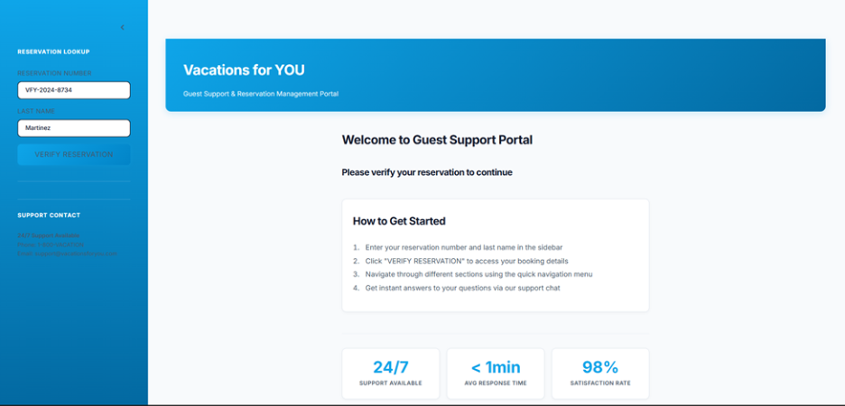

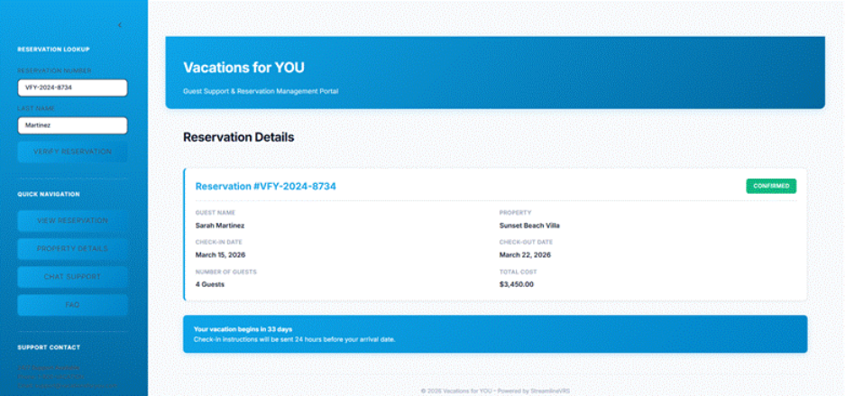

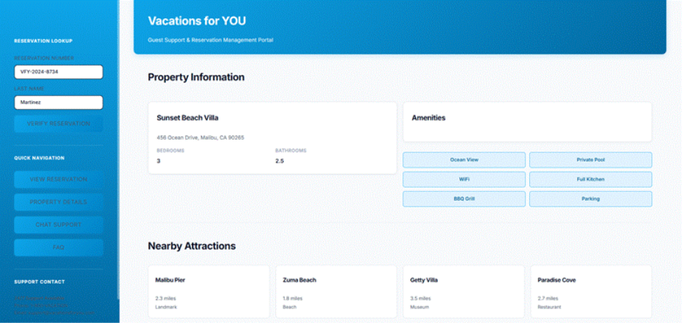

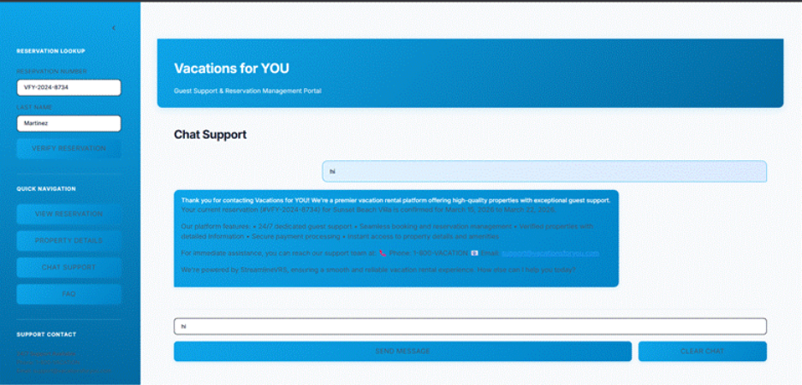

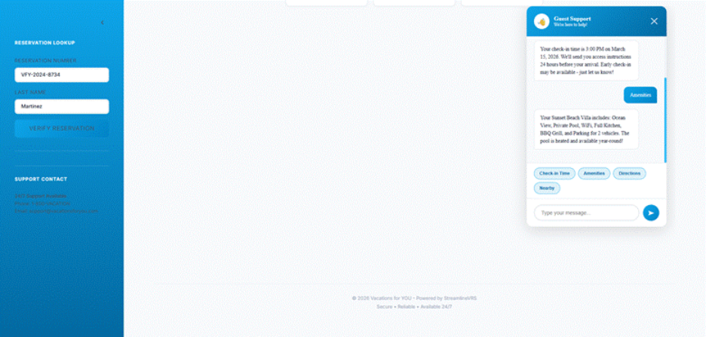

Users or Involved Personnel

End Users
Guests with confirmed reservations.
Note: This chatbot only assists the users with reservations.

Internal Stakeholders
- Project Sponsor (Vacations for You)
- Development Team (KSU Students Team-1)
- Call Center Representatives
The chatbot will serve as a first-level support system before escalating to human agents.
Note: As part of this POC, we will not be connecting the chat to any Agent. Instead, we will display a generic message that the Chatbot is unable to answer the user's question and suggest them to connect with the Customer support Team.

Development Background/Approach
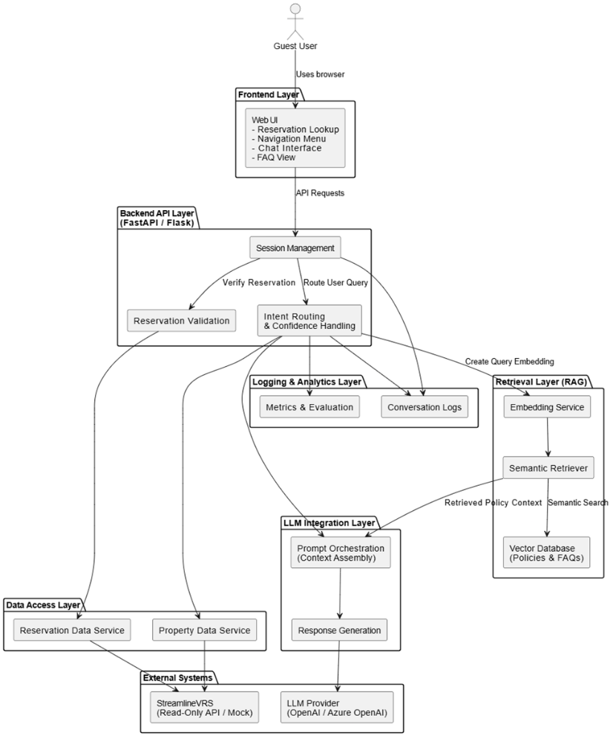

The system follows a modular, layered architecture:

Frontend Layer
- Web-based user interface
- Reservation verification form
- Chat interface and navigation components

Backend Layer
- API server handling session management and business logic
- Intent classification and response orchestration
- Confidence assessment and escalation logic

LLM Integration Layer
- Language model accessed via secure API [we might change to different LLM model later if we find a better alternative]
- Prompting constrained by validated context data.

Data Access Layer
- Abstracted integration with reservation and property data
- Mock data services for testing and development
- Public data sources for local attractions

API and Data Integration Plan

Data Sources
- Reservation and Property data: Reservation and Property Data from StreamX.
- Policy data: KnowledgeBase from Policy Document.

API Endpoints

Get Reservation Info:
- This endpoint needs to be used primarily to Validate the user by ReservationId, Name and by statusId.
- It could also be used to know the core Reservation Details and few details about the Property.
https://partner.streamlinevrs.com/apidocs/api-group/reservations/GetReservationInfo
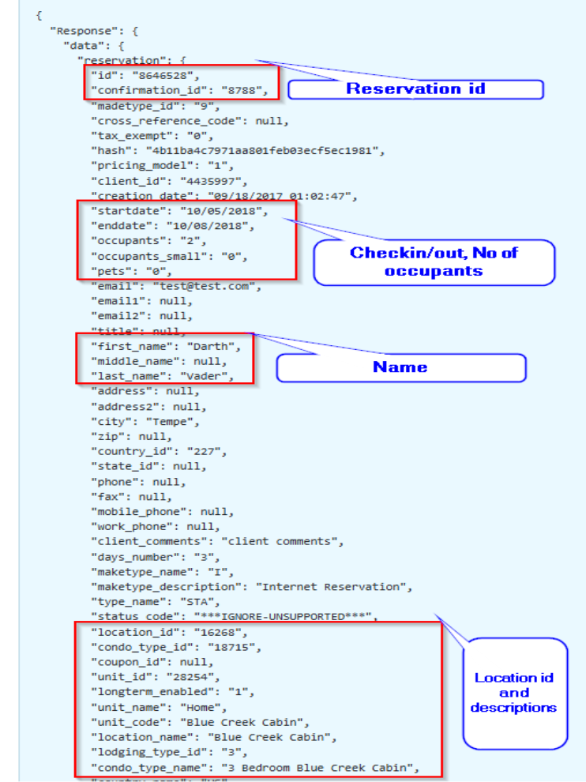
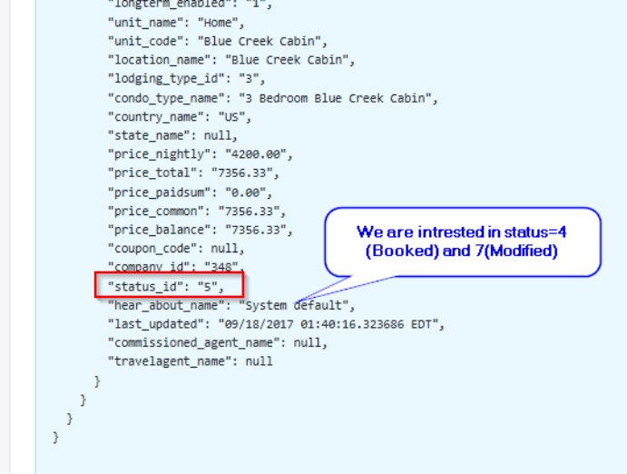

Get Property Info:
- We could use this endpoint to get more details about the Property.
- The response has the latitude, longitude, and zip code which could be useful in answering questions around places to visit nearby.
https://partner.streamlinevrs.com/apidocs/api-group/property_information/GetPropertyInfo

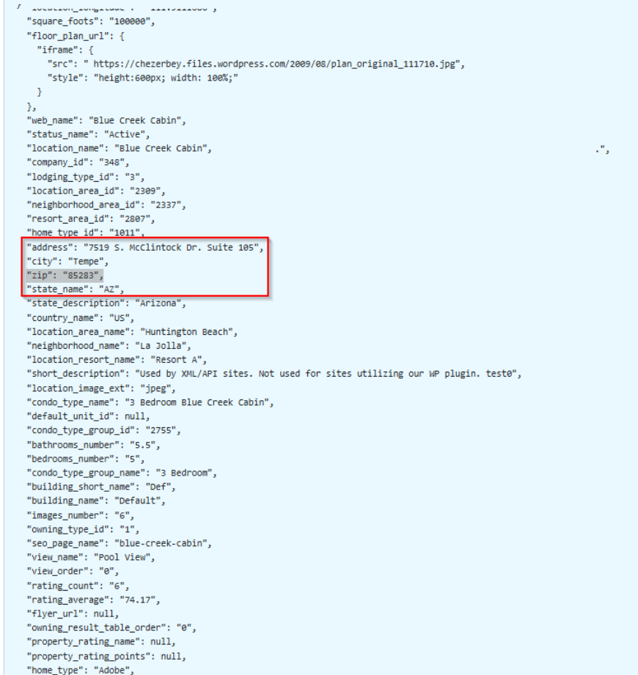

Get Property Amenities:
- This endpoint could be helpful to answer questions around Amenities of the Property. It would be better to call this endpoint to add this response data to the context.
https://partner.streamlinevrs.com/apidocs/api-group/property_information/GetPropertyAmenities

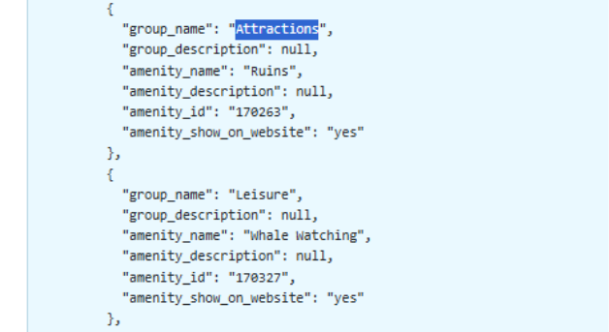

Integration Plan
- Implement a dedicated data access layer to isolate external dependencies.
- Support both mock and live API endpoints. Once we get the Token, we will switch from mock data to API Data.
- Enforce read-only access to all external systems.
- Normalize and validate data before use in response generation

High Level Estimates
The estimated timeline for the project is approximately 11 weeks.
Phase | Duration
Requirements & Design | 2 weeks
Architecture Setup | 2 weeks
RAG Implementation | 4 weeks
Testing & Evaluation | 2 weeks
Documentation & Finalization | 1 week

Evaluation Metrics

Accuracy Metrics
- Intent classification accuracy

- Response correctness against known reference data
- Hallucination and unsupported response rate

Coverage Metrics
- Percentage of inquiries resolved without escalation
- Distribution of supported versus unsupported intents

Operational Metrics
- Estimated call deflection rate
- Average response time
- Escalation frequency

Key Contacts and Stakeholders

The development team consists of:
- Team Lead : [John Pranoy] (Workstream: Architecture & RAG Integration): Owns the overall system architecture, RAG pipeline design, LLM configuration, and task assignment. Accountable for milestones in Sections 3.1.3 and 3.1.4.
- Team Member : [Walter Hernandez] (Workstream: Frontend): Responsible for the web-based chat interface, reservation verification form, and UI components. Accountable for Section 3.1.1 deliverables.
- Team Member : [Samir Mendrani] (Workstream: Tester): Responsible for End-to-end testing of the application from the Rest Endpoint Testing to the complete UI Testing.
- Team Member: [Varun Vemuri] (Workstream: Documentation & Development): Responsible for Documentation and creating a backend Rest API with Rate Limiter.
- Sponsor: Provides initial requirements, validation, and feedback on the developed product.
The updates will be shared with the client on a Teams call bi-weekly.

Features, Primary Deliverables, and External Commitments

Feature List
The Phase-1 POC will include:
- Reservation verification (Reservation ID + Last Name)
- Web-based chat interface
- Intent classification
- Context retrieval from APIs and policy documents
- RAG-based response generation
- Confidence-based escalation
- Logging for debugging and evaluation

Customer Deliverables
The final deliverables include:
- Working web-based POC chatbot
- Technical documentation
- Evaluation report (accuracy, escalation rate, performance)
- Presentation and working demonstration

Definition of Done (Success Criteria)
The POC is considered complete when all of the following conditions are met:
- The chatbot correctly answers at least 80% of a predefined test query set covering all supported question categories.
- Reservation verification works end-to-end using a valid reservation ID and guest last name against the StreamX API.
- The escalation path is demonstrated live: when confidence falls below threshold the system displays the support message instead of a response.
- Average response time is under 10 seconds on a standard network connection.
- A completed evaluation report documents accuracy, escalation rate, and response-time results with pass/fail status against each threshold.

Project Schedule

Date (YYYY-MM-DD) | Milestone/ task | Deliverable | Remarks
2026-01-15 | Requirements Finalization | Approved Requirements & Scope | Requirements reviewed with sponsor and finalized
2026-01-22 | Architecture Design Complete | System Architecture & RAG Design | High-level diagrams and data flow completed
2026-02-07 | Vector Database Setup | Policy Documents Embedded & Indexed | We have embedded a sample document. We are yet to implement the actual document received from client.
2026-02-21 | RAG Pipeline Functional | Context Retrieval + LLM Response Working | Done
2026-03-07 | Intent Classification & Confidence Scoring | Escalation Logic Implemented | Done
2026-03-14 | API Integration Implemented | Reservation & Property API Connectivity | Done
2026-03-21 | System Integration Testing | End-to-End Tested System | Done
2026-03-28 | Performance & Accuracy Evaluation | Evaluation Report | Done
2026-04-02 | Final Testing & Hallucination Fixes | Milestone 3 submission to Client | Done
2026-04-27 | Final Submission & Demonstration | Working POC + Documentation | Done

Project Resource Requirements

Staffing/ Skill Requirements
The project requires knowledge in:
- Web development (Frontend and backend)
- REST API integration
- Large Language Model integration
- Vector database usage for RAG Embedding
- Basic testing and debugging
- Version Control (Git)
All Team members are new to Retrieval Augmented Generation (RAG) systems and advanced LLM Integration. The Team is actively learning and building through online resources like articles and Tutorials. We will distribute the responsibilities based on our individual strengths while collaboratively learning and building.
We have built a simple app in Java to understand how RAG works with a simple Springboot REST backend API that uses Redis as a Vector DB for embedding and providing context to LLM. We are looking at Python backend application if that would be a better solution as it has more resources for LLM Integrations. We are yet to decide on the final Techstack and the LLM Model for the Project.
Role: Team Leader
Critical Skills
- Java Full Stack Developer
- Experience with Backend APIs
- Setting up GitHub Repository and API Tokens for LLM
Skill Gaps:
- Limited experience with Embedding models and Vector Databases.

Role: Team Members
Critical Skills: Developing Applications in Java and Python.
Skill Gaps: Limited exposure to LLMs and AI Models

Plan to Fill Skill Gaps
Any gaps in AI prompt design or vector database usage will be addressed through online tutorials from websites and YouTube to understand how RAG and Agentic AI work in the real world. We will also try to learn the concepts from LLM by asking it to break down the concepts. We will also have a group discussion where we share the challenges and suggest fixes to help each other to work as a Team. Also, because this is a POC, learning and iteration are expected parts of development.

Dependencies and Constraints

Constraints
The project has the following constraints:
- Read-only access to Customer API (StreamX)
- Dependency on the API availability (Most likely shouldn't be an Issue)
- Academic semester timeline
- Limited production-level infrastructure
- LLM Model’s limited capability on free tier. [Best Performance is not guaranteed as most free models are basic with limited capabilities which are not suitable for Industry level Project]

Risk Management
The following table identifies key project risks, their likelihood and impact, and the planned mitigation for each.

Risk | Likelihood | Impact | Mitigation
StreamX API access delays or token unavailability | Medium | High | Use mock data services during development and testing. Switch to live API only after credentials are confirmed. All API calls are abstracted behind a data access layer to allow seamless switching.
Scope creep beyond POC boundary | Medium | Medium | Maintain a clear supported vs unsupported question taxonomy (Section 2.5). Any new feature request must be logged and deferred to a future phase. The team lead reviews scope at each sprint review.
LLM free-tier limitations affecting response quality | High | Medium | Constrain prompts tightly so the model operates on structured context rather than open-ended generation. Evaluate alternative models if accuracy falls below 70% on test queries. The architecture is model-agnostic to allow substitution.
Evaluation challenges due to late test scenario definition | Medium | High | Define a minimum 30-query test set (covering all supported question categories) by the RAG Pipeline milestone on 2026-02-21. This gives the team adequate time to tune before the evaluation milestone on 2026-03-28.

Project Configuration and Data Management

Configuration Management
The Reservation Support Chat Platform will follow a simple but structured configuration management approach to ensure proper version control to ensure Stability throughout the Development.

Version Control
This Project will use Git for Version Control and GitHub as a central code repository. The source code and documentation will be stored in GitHub. The configuration secrets will be stored locally and not be committed to the repository.

Branching Strategy
The Team will follow basic branching model. After the initial setup we will push all the changes to main branch. Ideally, it is expected to be stable. So as and when the changes from feature branches are tested, we will push them to Project branch. After the end of each milestone, we will push the stable changes from the Project branch to the Main branch so that the Main branch stays stable.

Change Management
All feature branches need to be merged to Project branch via Pull Request. Towards the end of the milestone, the stable changes from the Project branch would be merged to the main branch via Pull Request. The Pull Request will have the Change details, description of the Fixes/features etc. Each Pull Request needs to be approved by at least one Team member before it can be merged. This ensures that the system remains stable.

Configuration Files
The sensitive information such as API Keys for LLMs and Database connection details will not be committed to GitHub. They will be stored in our local property files. For deployment on server, we will use GitHub secrets.

Project Process

Software Life Cycle Model
This Project will follow an Agile Development Model. The traditional Waterfall model might not be suitable for an AI-driven application as it would involve continuous development and changes related to prompts, retrieval logic, embeddings, confidence calculations, etc.
Development will occur in short sprints, allowing the team to:
- Build core functionality
- Test RAG retrieval accuracy
- Improve prompts
- Adjust confidence thresholds
Each sprint ends with testing and review and internal call discussing what went well and what could be done better for the next sprint.

Glossary
LLM – Large Language Model
POC – Proof of Concept
API – Application Programming Interface
Intent Classification – Identification of user query type
Escalation – Routing to human support

Change Record
Date | Version | Description | Author
2026-02-14 | 1.0 | Initial Project Plan Creation | John Pranoy Yalla, Walter Hernandez
2026-05-06 | 1.1 | Final Project Plan | John Pranoy Yalla, Samir Mendrani

